

**MATHEMATICS: SPECIALIST 1 & 2**

**SEMESTER 1 2019**

**TEST 3**

**Name_____________________**

**Calculator Free**

Time allowed: 20 mins Total marks: 19

**1.** [5 marks: 2, 3]

The position vectors of three points A ,B and C are $\left(1,3\right), \left(-2,6\right)$ and $(-5,10)$ respectively.

a) Find ${}_{B}^{}{r_{C}}$

b) Given that ${}_{D}^{}{r_{A}=(22,7)}$, find ${}_{B}^{}{r_{D}}$

**2.** [6 marks: 2, 2, 2]

Relative to a fixed point on the ground, Emirates flight EK16 has position vector $-3i+8j$.

a) The aircraft has a velocity of $6i+j$ km/min. Give the position vector of the flight after 30 minutes.

b) From the same fixed point, Qantas flight QF4 has position vector $10i-7j$.

i) Find the position vector of this aircraft relative to the original position of the Emirates flight.

ii) How far apart were the two aircraft? Give your answer as an exact value.

**3.** [6 marks: 3, 3]

(a) A triangle  has vertices ,  and . Determine the vector,  where M is the midpoint of side .

(b) is a triangle with point  on side  such that . If 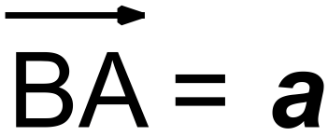 and 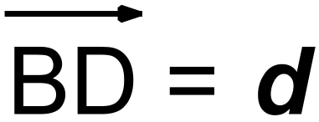 , show that 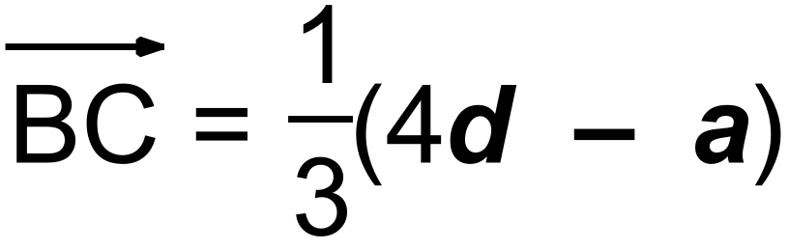.

**4.** [2 marks]

Prove that:



$${}_{m}^{}{v_{n}+{}_{n}^{}{v_{p}={}_{m}^{}{v_{p}}}}$$

**MATHEMATICS: SPECIALIST 1 & 2**

**SEMESTER 1 2019**

**TEST 3**

**Name_____________________**

**Calculator Assumed**

Time allowed: 35 mins Total marks: 28

**5.** [6 marks: 3, 3]

In each of the following diagrams, find the values of the letters. You should give reasons for your answers.

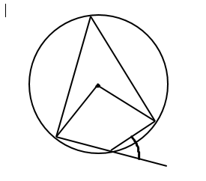

$$y$$

$$x$$

31°

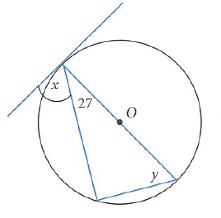

**6.** [9 marks: 4, 5]

Find the angles indicated in the diagrams below.

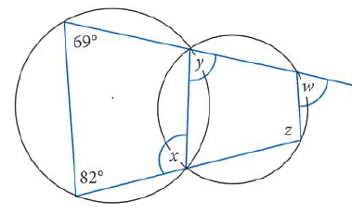

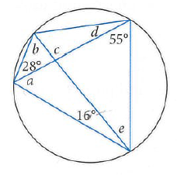

**7.** [3 marks]

Prove that A, B, C and D are concyclic, i.e. lie on the circumference of a circle.

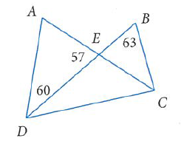

**8.** [4 marks]

Two straight lines, AB and CD, intersect at a point E. AE = 2cm, AB = 10cm, CE = 5cm and DE = 3.6cm. Using proof by contradiction, show that the two lines cannot be secants of a circle.

**8.** [6 marks]

To a person on a ship moving at 20km/h on a bearing 230° the wind appears to come from the North with speed 5km/h. Find the true velocity of the wind and the direction that it comes from.